1. What is the need for algorithm analysis? How would you perceive the best, worst and average case complexities? Give an example, along with a suitable graph. (7)
2. Explain the master's method for solving the recurrence relations. Solve the following recurrence relations using the master's method. (7)
   1. T(n) = 2T(n/4) + √n
   2. T(n) = 3T(n/2) + n
   3. T(n) = 4T(n/3) + n2
3. Explain Binary search tree. Write an algorithm to delete an element from BST and find its time complexity. (7)
4. Briefly explain a Queue and Priority Queue. Write algorithm to add and remove an element from the circular queue and compute the complexity of your algorithm. (8)
5. Write an algorithm for quick-sort and trace out the algorithm for the given array A [] = {-4, 1, 25, 50, 8, 10, 23}. (7)
6. What is the difference between fractional knapsack and 0/1 knapsack. Consider the following 7 items and the knapsack has capacity of 15. Find an optimal solution using fractional knapsack. (8)

| **Object(O)** | **1** | **2** | **3** | **4** | **5** | **6** | **7** |
| --- | --- | --- | --- | --- | --- | --- | --- |
| Profits(P) | 10 | 5 | 15 | 7 | 6 | 18 | 3 |
| Weights(w) | 2 | 3 | 5 | 7 | 1 | 4 | 1 |

1. Consider the set of given jobs as shown. Find a sequence of jobs, which will give maximum profit. (8)

| **Jobs** | **J1** | **J2** | **J3** | **J4** | **J5** | **J6** |
| --- | --- | --- | --- | --- | --- | --- |
| Deadlines | 5 | 3 | 3 | 2 | 4 | 2 |
| Profits | 200 | 180 | 190 | 300 | 120 | 100 |

1. What is the real-life application of tree vertex splitting problem? For δ = 5, add booster to the following tree. (8)

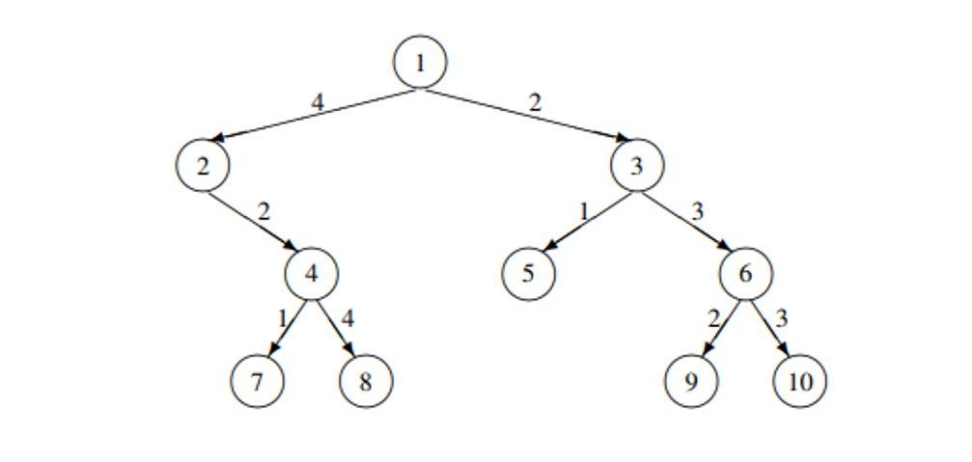

1. Explain and analyze the Floyd’s Warshall algorithm for all pair shortest path problem. Trace the algorithm with suitable example. (8)
2. What is the optimal binary search tree? Using dynamic approach, build optimal binary tree for the given values. (8)

| Keys | 10 | 20 | 30 | 40 |
| --- | --- | --- | --- | --- |
| Frequency | 4 | 2 | 6 | 3 |

1. What is the backtracking method for problem solving? Explain how you solve the 8-queen problem using the backtracking method. (7)
2. Define articulation point and bi-connected component of the graph? Write the algorithm for finding articulation point in the graph with suitable example. (7)
3. Write short notes on: (Any two) (2*5)
   1. Graph Coloring Problem
   2. Optimal merge patterns
   3. Travelling salesman problem.